GFMI Switching Model – Richardson Extrapolation
The objective of this test was to investigate whether Richardson extrapolation can accurately estimate the dq admittance of a switching grid-forming inverter using larger solver timesteps instead of an extremely small reference timestep.
In addition to comparing numerical errors, this study investigates why the three-level mixed Richardson method does not outperform conventional second-order Richardson, even though it formally cancels both first- and second-order timestep-error terms. Held-out prediction, complex-error trajectories, convergence-order stability and extrapolation sensitivity are used to determine whether the assumed error models remain valid across the tested timesteps.
The switching GFMI contains a 5 kHz PWM stage, so the solver timestep must be sufficiently small to represent the switching behaviour. The main practical timestep levels investigated were 12.5 us, 6.25 us, 3.125 us, and a very fine 0.1us simulation was used only as a validation reference.
The test was carried out at 3 perturbation frequencies (1 Hz, 5 Hz, and 10Hz) to determine the frequency range over which Richardson extrapolation remains reliable.
Parameter | Value
Converter type | Switching GFMI
PWM frequency | 5 kHz
Coarse solver timestep | 12.5 µs
Fine solver timestep | 6.25 µs
Finer solver timestep | 3.125 us
Validation reference timestep | 0.1 µs
Logging interval | 25 µs
Logging frequency | 40 kHz
Moving-average window | 8 logged samples
Moving-average duration | 200 µs
LPF type | Fourth-order Butterworth, zero phase
LPF cutoff | 100 Hz
Phasor window | 3–10 s
Perturbation frequencies | 1, 5 and 10 Hz
Perturbation amplitude | d-axis: 0.01 p.u.  q-axis: 0.5 degrees

Raw-Waveform vs Envelope-Based Richardson
The switching GFMI contains high-frequency PWM ripple around 5 kHz. Therefore, the effect of extracting the low-frequency switching envelope before Richardson extrapolation was investigated.
Two processing methods were compared.
Raw method: Richardson was applied without the moving-average and low-pass filtering stage.
Envelope method: a one-PWM-period moving average followed by a zero-phase 100 Hz low-pass filter was applied before Richardson extrapolation.
Since Tpwm = 1/5k = 200 us and the logging interval was 25 µs, the moving-average window contained N=200/25 = 8 logged samples.
Frequency | Raw RE matrix error | Envelope RE matrix error | Lower error
1 Hz | 0.0105% | 0.0098% | Envelope
5 Hz | 0.2268% | 0.2012% | Envelope
10 Hz | 1.3941% | 1.3589% | Envelope
Envelope extraction produced the lower complete-matrix error at all three tested frequencies.
The improvement was moderate rather than dramatic. This is reasonable because the least-squares phasor extraction only estimates the intentionally injected 1, 5 or 10 Hz component. Most of the 5 kHz PWM content is therefore naturally rejected during low-frequency phasor estimation.
However, the raw coarse-to-fine current difference contained more high-frequency ripple. At 10 Hz raw peak-to-peak = 0.00100526 while envelope peak-to-peak = 0.00082178.
Therefore, raw/envelope = 1.223
The raw difference contained approximately 22.3% more peak-to-peak variation than the envelope result.
Raw-waveform Richardson therefore remained usable for the tested low-frequency points, but it was more sensitive to switching ripple. Envelope extraction gave a cleaner coarse-to-fine difference and consistently lower complete-matrix errors. Therefore, the envelope-based workflow was retained for the final switching-GFMI analysis. This is consistent with the envelope-processing approach already used in the earlier switching-model note.
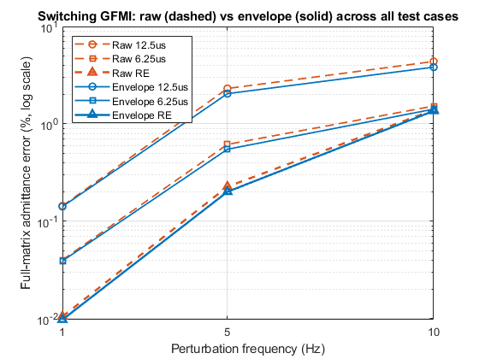 | 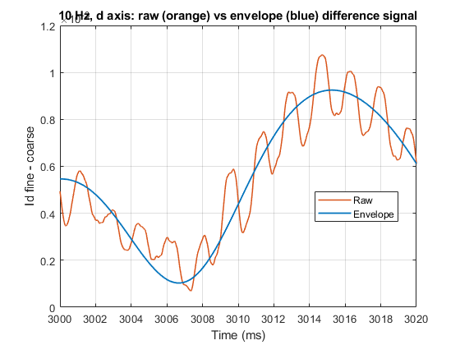
Figure 1 shows the complete-matrix error versus perturbation frequency for the raw and envelope workflows. The envelope results are consistently slightly below the raw results.
Figure 2 shows the 10 Hz coarse-to-fine current difference used by Richardson. The raw difference contains visible high-frequency ripple, while the envelope difference is much smoother. The raw difference peak-to-peak value was approximately 1.223 times the envelope value.

Matlab workflow
- Import the PSCAD CSV files for the 12.5, 6.25, 3.125 and 0.1 µs simulations.
- Verify that all simulations contain identical logged timestamps.
- Apply a one-PWM-period moving average to the raw abc voltages and currents.
- Apply a fourth-order 100 Hz zero-phase Butterworth low-pass filter.
- Estimate the dq reference angle from the unperturbed 0.5–1.9 s interval.
- Estimate the d-run and q-run reference angles separately and calculate their circular mean.
- Convert all filtered abc signals into dq quantities using the same common reference angle.
- Apply Richardson extrapolation to the filtered dq waveforms.
- Extract the perturbation-frequency phasors using a least-squares sinusoidal fit over 3–10 s.
- Form the complete voltage and current matrices.
- Calculate the dq admittance.
- In MATLAB, right matrix division was used. Y = I/V
- Compare each practical and extrapolated result against the 0.1 µs reference.
- Check:
- voltage/current waveform errors;
- complete dq-admittance matrix error;
- individual admittance-element errors;
- observed convergence order;
- complex error-ratio angle;
- voltage-matrix condition number.

Richardson Equations

First-order Richardson
For timestep ratio r= 12.5/6.25 = 2 and assumed order p =1,
$$y_{RE,1}=y_{6.25}+\frac{y_{6.25}-y_{12.5}}{2^{1}-1}$$
Therefore
$$y_{RE,1}={2y}_{6.25}-y_{12.5}$$
This method requires 12.5us and 6.25us simulations.

Second-order Richardson
For p=2 ,
$$y_{RE,2}=\frac{4y_{6.25}-y_{12.5}}{3}$$
This also requires only 12.5us and 6.25us simulations.

Mixed h+ h² Richardson
A three-level extrapolation was also tested:
$$y_{mixed}=\frac{y_{12.5}}{3}-2y_{6.25}+\frac{8}{3}y_{3.125}$$
This combination cancels first- and second-order timestep terms.
It requires 12.5, 6.25, and 3.125 us simulations.
However, this cancellation only produces an improved result if the timestep errors follow a sufficiently stable expansion over the three timestep levels.

Residual-error interpretation
For a fixed perturbation frequency, the calculated switching-model admittance may be represented locally as
$$Y\left(h , f\right)=Y_{0}\left(f\right)+C_{1}\left(f\right)h+C_{2}\left(f\right)h^{2}+C_{3}\left(f\right)h^{3}+⋯+E_{PWM}\left(h , f\right),$$
where $Y_{0}$is the unknown zero-timestep admittance. The terms $C_{k}h^{k}$represent smooth timestep-dependent errors, while $E_{PWM}$ represents additional effects associated with the discrete representation of PWM switching events and subsequent envelope processing.
Conventional second-order Richardson uses the 12.5 and 6.25 µs results:
$$Y_{RE2}=\frac{4Y_{6.25}-Y_{12.5}}{3}.$$
If the dominant error is $C_{2}h^{2}$, this combination cancels that term and leaves higher-order residual errors.
Mixed Richardson uses 12.5, 6.25 and 3.125 µs:
$$Y_{mixed}=\frac{1}{3}Y_{12.5}-2Y_{6.25}+\frac{8}{3}Y_{3.125}.$$
It cancels both $C_{1}h$and $C_{2}h^{2}$. However, this provides an improvement only when the same coefficients describe all three timestep results. If higher-order, PWM-related or phase-dependent effects change across the timestep range, the mixed method may fit those variations rather than a stable $h+h^{2}$error law. Cancelling more formal terms therefore does not automatically guarantee a smaller total residual error.

Results
Overall matrix error relative to the 0.1us solver step reference.
Frequency | 12.5 µs | 6.25 µs | 3.125 µs | p=1 RE | p=2 RE | Mixed RE | Lowest error RE
1 Hz | 0.141832% | 0.039235% | 0.009942% | 0.065992% | 0.009786% | 0.009909% | p=2 RE
5 Hz | 2.044435% | 0.549531% | 0.186595% | 1.048940% | 0.201158% | 0.390338% | p=2 RE
10 Hz | 3.826091% | 1.418587% | 0.178355% | 2.691989% | 1.358913% | 2.233414% | p=2 RE

The results show that Richardson behaviour is strongly frequency-dependent.
At 1 Hz, 5 Hz, and 10 Hz, p=2 Richardson produced the lowest complete-matrix error.

Held-out error model prediction
A held-out prediction test was performed to determine whether the assumed error models could predict an independently simulated finer result. The direct admittances at 12.5, 6.25 and 3.125 µs were used to fit:
$$Y_{p2}\left(h\right)=A_{0}+A_{2}h^{2}$$
and
$$Y_{mixed}\left(h\right)=B_{0}+B_{1}h+B_{2}h^{2}.$$
Both models were evaluated at 0.1 µs and compared with the direct 0.1 µs simulation. In this test, the direct 0.1 µs result is the known prediction target, not the exact zero-step solution.
The $p=2$ model was fitted by least squares using all three practical timestep results. This three-level fit was used only as a diagnostic of second-order consistency. It must not be confused with the practical $p=2$ Richardson formula, which uses only the 12.5 and 6.25 µs simulations.
Frequency | Fitted $p=2$prediction error | Mixed prediction error | Lower prediction error
1 Hz | 0.005306% | 0.009473% | $$p=2$$
5 Hz | 0.081264% | 0.379880% | $$p=2$$
10 Hz | 0.518451% | 2.119055% | $$p=2$$

At 1 Hz, both models predicted the held-out result accurately, although $p=2$ was lower overall. At 5 Hz, the mixed prediction error was approximately 4.68 times the $p=2$ error. At 10 Hz, it was approximately 4.09 times the $p=2$ error.
Because the mixed model has three coefficients and uses three training timesteps, it passes exactly through the training data. Its poorer prediction of the unseen 0.1 µs result shows that this exact training fit does not generalise toward the finer solution. The additional fitted linear term is therefore likely absorbing non-stable higher-order, PWM-related, or processing-dependent behaviour.

Extrapolation sensitivity
The absolute sum of the extrapolation coefficients provides a simple worst-case measure of sensitivity to inconsistencies in the input data.
For $p=2$ Richardson:
$$S_{p2}=∣-\frac{1}{3}∣+∣\frac{4}{3}∣=\frac{5}{3}.$$
For mixed Richardson:
$$S_{mixed}=∣\frac{1}{3}∣+∣-2∣+∣\frac{8}{3}∣=5.$$
The mixed method therefore has three times the simple worst-case input-error sensitivity of $p=2$ Richardson. This does not mean its actual error must always be three times larger. It means that small inconsistencies between timestep simulations can be amplified more strongly by the mixed combination.

Results at 1 Hz
d-axis perturbation
Method | Voltage error | Current error
12.5 µs | 0.085812% | 0.391946%
6.25 µs | 0.021511% | 0.098741%
3.125 µs | 0.005459% | 0.026043%
p=1 RE | 0.044079% | 0.215039%
p=2 RE | 0.004988% | 0.043283%
Mixed RE | 0.008568% | 0.072644%
q-axis perturbation
Method | Voltage error | Current error
12.5 µs | 0.085890% | 0.395103%
6.25 µs | 0.021401% | 0.099316%
3.125 µs | 0.005589% | 0.030445%
p=1 RE | 0.043845% | 0.213453%
p=2 RE | 0.003825% | 0.039338%
Mixed RE | 0.007396% | 0.077047%
Second-order Richardson significantly reduced the waveform error at 1 Hz.
Full Admittance-Matrix Error
Method | Error
12.5 µs | 0.141832%
6.25 µs | 0.039235%
3.125 µs | 0.009942%
p=1 RE | 0.065992%
p=2 RE | 0.009786%
Mixed RE | 0.009909%
The p=2 and mixed estimates are extremely close.
Therefore, both extrapolation methods provide essentially the same very high accuracy at 1 Hz, with p=2 marginally lower.
Element-wise Errors
Element | 12.5 µs | 6.25 µs | 3.125 µs | p=1 RE | p=2 RE | Mixed RE
Ydd | 0.331016% | 0.084988% | 0.026089% | 0.167512% | 0.020905% | 0.013796%
Ydq | 0.305920% | 0.084496% | 0.016799% | 0.142010% | 0.020208% | 0.027805%
Yqd | 0.083471% | 0.026357% | 0.007555% | 0.030902% | 0.007351% | 0.005106%
Yqq | 0.318456% | 0.070547% | 0.017401% | 0.177921% | 0.012607% | 0.013911%
No single extrapolation method gives the minimum error for all four elements, but all errors remain extremely small.
Observed Convergence
Element | p, 12.5→6.25 | Angle | p, 6.25→3.125 | Angle
Ydd | 1.9616 | 10.59° | 1.7038 | 7.29°
Ydq | 1.8562 | -9.20° | 2.3305 | -1.85°
Yqd | 1.6631 | -1.59° | 1.8028 | 3.00°
Yqq | 2.1744 | 1.85° | 2.0194 | -5.87°
The observed orders remain reasonably close to second-order behaviour and the complex error-ratio angles remain comparatively small.
This explains why second-order Richardson works particularly well at 1 Hz.
1 Hz Conclusion
At 1 Hz, $p=2$ Richardson produced a complete-matrix discrepancy of 0.009786%, compared with 0.009909% for mixed Richardson. The difference is very small, so the two methods are practically equivalent in accuracy. Nevertheless, $p=2$is preferred because it requires only the 12.5 and 6.25 µs simulations, whereas mixed Richardson additionally requires the 3.125 µs simulation. The held-out prediction test also favoured the $p=2$ error model. Therefore, $p=2$provides the better accuracy-runtime trade-off at 1 Hz.

Results at 5 Hz
Waveform Errors
d-axis perturbation
Method | Voltage error | Current error
12.5 µs | 0.086604% | 0.401358%
6.25 µs | 0.021643% | 0.100034%
3.125 µs | 0.005385% | 0.024692%
p=1 RE | 0.044000% | 0.212897%
p=2 RE | 0.003636% | 0.032687%
Mixed RE | 0.006947% | 0.058902%
q-axis perturbation
Method | Voltage error | Current error
12.5 µs | 0.086044% | 0.395084%
6.25 µs | 0.021770% | 0.101752%
3.125 µs | 0.005578% | 0.027731%
p=1 RE | 0.043905% | 0.212467%
p=2 RE | 0.005199% | 0.043489%
Mixed RE | 0.009040% | 0.077149%

Complete dq-Admittance Matrix Error
Method | Error
12.5 µs | 2.044435%
6.25 µs | 0.549531%
3.125 µs | 0.186595%
p=1 RE | 1.048940%
p=2 RE | 0.201158%
Mixed RE | 0.390338%
The p=2 result improves the direct 6.25 µs result by, 0.549531/0.201158 = 2.73.
Therefore, p=2 Richardson reduces the full-matrix error by approximately 2.73 times compared with the direct 6.25 µs simulation.
Element-Wise Errors
Element | 12.5 µs | 6.25 µs | 3.125 µs | p=1 RE | p=2 RE | Mixed RE
Ydd | 1.813391% | 0.138828% | 0.163129% | 1.580840% | 0.443851% | 0.775259%
Ydq | 2.247769% | 0.631281% | 0.204958% | 1.041453% | 0.157064% | 0.333435%
Yqd | 0.382384% | 0.084379% | 0.040780% | 0.353047% | 0.132214% | 0.162618%
Yqq | 2.486504% | 0.622340% | 0.232225% | 1.279257% | 0.094204% | 0.517320%
The element-wise behaviour is mixed.
p=2 gives strong improvement for Ydq and Yqq, while direct refinement performs better for Ydd and Yqd.
Observed Convergence
Element | R, 12.5→6.25 | Angle | R, 6.25→3.125 | Angle
Ydd | 3.7073 | -21.99° | -0.2327 | 9.61°
Ydq | 1.8321 | 9.95° | 1.6230 | -22.52°
Yqd | 2.1801 | -65.63° | 1.0490 | 24.27°
Yqq | 1.9983 | 7.09° | 1.4222 | -42.81°
The convergence behaviour changes more significantly at 5 Hz.
For example, changes from 3.71 to -0.23.
This indicates that the numerical error is not following one stable power-law expansion over the three timestep levels.
Why Mixed Richardson Does Not Give the Best 5 Hz Result
Mixed Richardson cancels both h and h² terms only if the errors follow a stable expansion:
Y(h) = Y₀ + C₁h + C₂h² + …
At 5 Hz, the observed convergence orders and complex error directions change between timestep intervals.
Therefore, the coefficients associated with the timestep-error expansion are not behaving consistently enough for the mixed extrapolation to cancel the errors cleanly.
As a result, mixed RE error is worse than second-order Richardson.
5 Hz Conclusion
At 5 Hz, $p=2$ Richardson produced a complete-matrix discrepancy of 0.201158%, compared with 0.390338% for mixed Richardson. The fitted $p=2$ model also predicted the held-out 0.1 µs result with 0.081264% error, while the mixed prediction error was 0.379880%.
The observed convergence order and complex-error direction changed between timestep pairs, and $Y_{dd}$displayed non-monotonic convergence between 6.25 and 3.125 µs. Therefore, the three practical results do not follow one stable $h+h^{2}$ trajectory. The mixed model fits these irregular changes but does not generalise to the held-out result. $p=2$ Richardson is therefore the preferred accelerated method at 5 Hz.

Results at 10 Hz
Waveform errors
d-axis perturbation
Method | Voltage error | Current error
12.5 µs | 0.086500% | 0.401161%
6.25 µs | 0.021667% | 0.099925%
3.125 µs | 0.006219% | 0.036333%
p=1 RE | 0.043559% | 0.209551%
p=2 RE | 0.002756% | 0.027432%
Mixed RE | 0.004062% | 0.035940%
q-axis perturbation
Method | Voltage error | Current error
12.5 µs | 0.085855% | 0.390572%
6.25 µs | 0.023603% | 0.125275%
3.125 µs | 0.005308% | 0.023348%
p=1 RE | 0.045883% | 0.236586%
p=2 RE | 0.012000% | 0.097154%
Mixed RE | 0.018686% | 0.151466%
The waveform results demonstrate that a better extrapolated voltage or current signal does not automatically produce a better final admittance matrix.
Complete dq-Admittance Matrix Error
Method | Error
12.5 µs | 3.826091%
6.25 µs | 1.418587%
3.125 µs | 0.178355%
p=1 RE | 2.691989%
p=2 RE | 1.358913%
Mixed RE | 2.233414%
Second-order Richardson only slightly improves the direct 6.25 µs result.
Element-Wise Errors
Element | 12.5 µs | 6.25 µs | 3.125 µs | p=1 RE | p=2 RE | Mixed RE
Ydd | 5.562238% | 1.053207% | 0.342945% | 4.353372% | 1.399750% | 2.551755%
Ydq | 4.019731% | 1.851635% | 0.069395% | 2.203186% | 1.545387% | 2.577986%
Yqd | 1.536932% | 0.429752% | 0.054602% | 1.722690% | 0.763091% | 1.028151%
Yqq | 4.203266% | 2.327589% | 0.294564% | 2.838863% | 2.169112% | 3.198057%
Direct 3.125 µs simulation gives the lowest error for all four admittance elements.
p=2 gives an improvement for Ydq and Yqq, while direct refinement performs better for Ydd and Yqd.
Observed Convergence
Element | p, 12.5→6.25 | Angle | p, 6.25→3.125 | Angle
Ydd | 2.4009 | -48.95° | 1.6187 | 101.11°
Ydq | 1.1183 | -33.12° | 4.7378 | -51.74°
Yqd | 1.8385 | -89.99° | 2.9765 | -125.07°
Yqq | 0.8527 | -37.10° | 2.9822 | -59.17°

The numerical convergence behaviour changes significantly between timestep intervals.
For example: Ydq: 1.12 to 4.74
The complex error direction also changes substantially.
This means that the timestep error is not following a stable single-power or mixed first/second-order model over the tested timestep range.
Why the Frequency Change Matters
Only the perturbation frequency was changed between the 1, 5 and 10 Hz cases. However, the GFMI is a dynamic system, and its admittance is frequency-dependent:
Y = Y(jw).
The numerical timestep error can therefore also depend on frequency:
E(h,w) = C₁(w)h + C₂ (w)h² + C₃(w)h³ + …
At 1 Hz, the numerical error behaves approximately like a stable second-order term, so p=2 Richardson performs very well.
At 5 and especially 10 Hz, the observed convergence order and complex error direction change significantly as the timestep is refined.
The direct solutions still converge strongly; the switching simulation itself is converging.
The issue is that the errors between successive timestep levels no longer follow one stable h^{p} relationship. Richardson extrapolation therefore becomes less reliable.
Why Mixed Richardson Performs Poorly at 10 Hz
Mixed Richardson is theoretically capable of cancelling both h and h² terms.
However, this requires the numerical error to follow:
Y(h) = Y₀ + C₁h + C₂h² + …
with reasonably stable coefficients over the three timestep levels.
At 10 Hz, the observed orders and error directions change strongly.
The switching model also contains several numerical stages:
PWM switching → envelope extraction → dq → phasor fitting → V/I matrices → Y
Small timestep-dependent switching-edge and phase errors can therefore propagate into the low-frequency phasors.
When the error no longer follows the assumed smooth expansion, the mixed coefficients can amplify residual differences instead of cancelling them.
10 Hz Conclusion
At 10 Hz, $p=2$ Richardson produced a complete-matrix discrepancy of 1.358913%, compared with 2.233414% for mixed Richardson. The held-out prediction errors were 0.518451% and 2.119055%, respectively.
The convergence orders and complex-error directions changed substantially between timestep pairs, and the fitted complex trajectories did not approach the finer result along one smooth quadratic path. This demonstrates that the mixed method’s assumed $h+h^{2}$ error expansion is not stable over the selected timestep range.
Therefore, $p=2$ remains the preferred Richardson method at 10 Hz because it is more accurate than mixed and requires one fewer timestep level. However, its 1.358913% discrepancy is higher than at 1 and 5 Hz, demonstrating that Richardson reliability decreases with perturbation frequency. Whether this error is acceptable must be determined from the application’s required accuracy threshold.

Frequency Dependence
The results show that the effectiveness of second-order Richardson extrapolation decreases as the perturbation frequency increases.
Frequency | 6.25 µs direct error | p = 2 Richardson error
1 Hz | 0.039235% | 0.009786%
5 Hz | 0.549531% | 0.201158%
10 Hz | 1.418587% | 1.358913%
At 1 Hz, Richardson extrapolation gives a strong improvement. At 5 Hz, it still provides a clear reduction in the complete dq-admittance matrix error. At 10 Hz, the improvement is smaller, but the Richardson result remains slightly more accurate than the direct 6.25 µs result.
Overall, p = 2 Richardson extrapolation improves the complete-matrix result at all three tested frequencies, showing that Richardson extrapolation can also be applied to the switching GFMI model. Its effectiveness, however, becomes weaker as frequency increases.

Limitations
The 0.1 µs simulation is a very fine validation reference but remains a finite-timestep solution. Therefore, the reported values measure discrepancy relative to this reference rather than exact error relative to the unknown $Y_{0}$.
The present analysis demonstrates that the mixed $h+h^{2}$model does not describe the observed switching-model convergence reliably. It does not uniquely separate the contributions of $h^{3}$, $h^{4}$, PWM timing, envelope extraction and other numerical effects.
The results were obtained at one operating point and three perturbation frequencies. Additional operating-point testing is required before claiming that the same accuracy and frequency dependence apply throughout the complete GFMI operating range.

Failure conditions
The method should not be accepted when:
- the time vectors do not match
- the physical model changes between simulations
- the operating point changes
- the voltage matrix is poorly conditioned
- Richardson does not beat the fine result
- the observed order is far from two
- the complex error-ratio angle is large
- the perturbation is nonlinear
- the phasor window contains too few cycles
- the result depends strongly on the filtering settings.

Runtime and accuracy
Frequency | Four practical PSCAD runs | MATLAB processing | Richardson total | Two (0.1us) reference runs | Speed-up
1 Hz | 75.37+60.28+79.87+61.35 | 4.7127 | 281.5827 | 2248.72+2210.73= 4459.45 | 15.8x
5 Hz | 78.71+60.40+80.07+60.89 | 4.7692 | 284.8392 | 1996.98+2042.26 = 4039.24 | 14.18x
10 Hz | 78.17+60.87+78.99+61.07 | 4.6065 | 283.7065 | 1973.26+2016.40 = 3989.66 | 14.06x

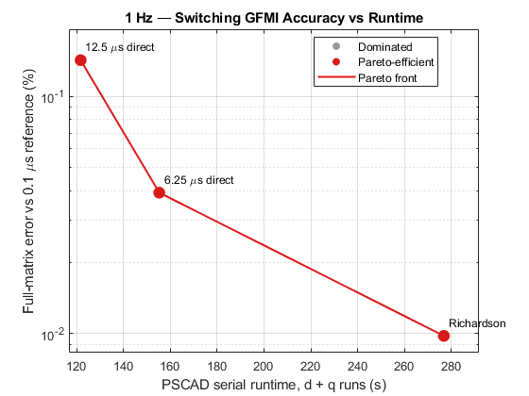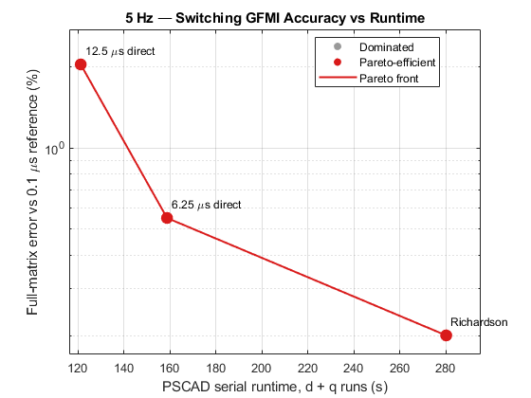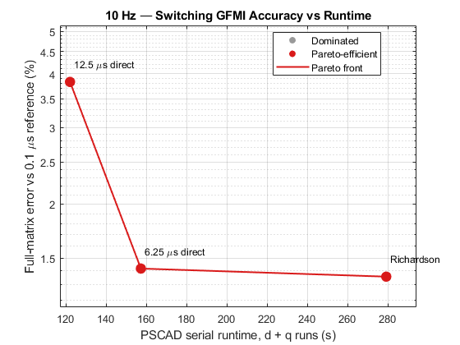

The Pareto results show that second-order Richardson provides a substantial accuracy improvement for a moderate increase in runtime at 1 Hz and 5 Hz. At 10 Hz, the accuracy improvement over the direct 6.25 µs simulation is smaller, consistent with the frequency-dependent behaviour observed above.

Conclusion
The switching GFMI Richardson investigation demonstrates that:
- Envelope extraction reduces the influence of PWM ripple before extrapolation.
- Second-order Richardson improves the complete $dq$-admittance matrix relative to the direct 6.25 µs result at all three tested frequencies.
- The greatest improvement occurs at 1 Hz, where second-order Richardson reduces the matrix discrepancy from 0.039235% to 0.009786%.
- Richardson remains clearly beneficial at 5 Hz, reducing the discrepancy from 0.549531% to 0.201158%.
- At 10 Hz, the improvement is smaller but still positive, reducing the discrepancy from 1.418587% to 1.358913%.
- Second-order Richardson is the preferred accelerated method because it requires only the 12.5 and 6.25 µs simulations and gives lower error than the three-level mixed method at every tested frequency.
- Although mixed Richardson formally cancels both $h$and $h^{2}$error terms, it does not give better results because the switching-model error does not follow one stable $h+h^{2}$relationship across all three timesteps.
- The changing convergence orders and complex error directions, particularly at 5 and 10 Hz, indicate the presence of higher-order, PWM-related and other non-asymptotic effects.
- The held-out prediction test confirms that the second-order error model predicts the independently simulated 0.1 µs result more accurately than the mixed model at all three frequencies.
- Voltage-matrix conditioning and the location of Richardson processing were ruled out as the main causes because the matrices were well-conditioned and waveform-level and admittance-level extrapolation produced similar results.
Overall, second-order Richardson extrapolation provides the best accuracy-runtime trade-off for switching-GFMI admittance estimation over the tested 1–10 Hz range. Its effectiveness is frequency-dependent, with the largest benefit at low frequency and decreasing improvement as frequency increases. The main finding is that cancelling more formal error terms does not necessarily produce a better result unless the timestep errors follow a stable expansion over the selected timestep range.

Richardson qualification rule
The admittance errors were also examined to determine whether they followed the assumed second-order timestep behaviour. For ideal second-order convergence, the complex coarse-to-fine error ratio should be approximately 4. This means that the observed convergence order should be close to two and the coarse and fine errors should point in approximately the same direction in the complex plane. For this preliminary investigation, an admittance element was classified as qualified when
$$∣p_{observed}-2∣<0.5$$
and
$$∣∠\left(E_{c}/E_{f}\right)∣<{20}^{∘},$$
where
$$E_{c}=Y_{c}-Y_{ref}, E_{f}=Y_{f}-Y_{ref}.$$
Richardson was recommended only when the element passed these convergence checks, and the Richardson error was lower than the direct 6.25 µs error. Otherwise, the 6.25 µs result was retained as the practical fallback. The table summarises the qualification results for all four dq admittance elements at the three tested frequencies.

